**Utility Function**

• Requires #include <cstdlib>

• Exit Program – exit(int i) – void function

**Math Functions**

• Requires #include <cmath> or #include <cstdlib>

o Square Root– sqrt(double x) - returns a double

o Exponent – pow(double x, double e) - returns a double

o Absolute Value – abs(int x) - returns an int

o Ceiling – ceil(double x)- returns a double; jumps up

o Floor - floor(double x)- returns a double; drops down

o Round - round(double x)-round up or down to the nearest integer

**Pseudorandom numbers**

o rand() – returns an int

o srand() – sets the starting seed

o srand(time(NULL))

* set the starting seed using the current time
* requires #include <time.h>

**Order of Precedence**

Priority 1

. dot operator

[] array index

( ) function call

n++ postfix increment operator

n-- postfix decrement operator

static_cast cast operation

Priority 2 (Right-to-Left)

++n prefix increment operator

--n prefix decrement operator

! not

- unary minus

+ unary plus

Priority 3

* multiply

/ divide

% modulo

Priority 4

+ addition

- subtraction

Priority 5

<< insertion operator

>> extraction operator

Priority 6

< less than

> greater than

Priority 7

== equivalence

!= equivalence negation

Priority 8

&& and

Priority 9

|| or

Priority 10 (Right-to-Left)

= assignment

+= add and assign

-= subtract and assign

*= multiply and assign

/= divide and assign

%/ modulo and assign

Priority 11

, comma

**Identifiers**

• Primitive Data Types (Variables)

Case sensitive

Must start with a letter or underscore

Can use letters, digits or underscore are acceptable

Types

integer

short: -32,768 - 32,767

int: -2,147,483,648 - 2,147,483,648

long: -2,147,483,648 - 2,147,483,648

floating point

float: 10-38 to 1038

double: 10-308 to 10308

char

any single ASCII character

see ASCII table

bool

1 or 0 represents true or false

Any number aside from 0 will evaluate as true.

Class Data Type (Variables)

string

Requires #include <string>

Includes a variety of string manipulation options

Constants

constant variables are named in upper case

Syntax: const var_type var_name = literal;

Example: const string PAYDAY = “Friday”;

**Casting**

converting data types

Syntax: type variable Name = static_cast<type>(data);

int x = 5;

double quotient = static_cast<double>(x);

Used in converting cases Upper to Lower & Lower to Upper

**String Variables**

o String variables are used to store string literals.

Recall that a string literal is composed of one or more characters.

Characters:

‘A’, ‘b’, ‘&’, ‘_’, ‘\n’, ‘ ‘

o A string literal can be **assigned** or stored into a string variable using

the following syntax:

**string name = “John”;**

**String Functions**

o A **function** is a group of related commands which can be executed on demand.

Main is the primary function of a C++ program. Executing a function is referred to as a **function call**. Each function has a **name** and can accept input through **parameters**. Finally, functions may **return** data (a result of the commands) to the calling function.

o There are a variety of functions available for string objects, some of which are described here. To insure compatibility across multiple compilers the **string library** should be included at the top of the program to support these functions (in addition to **iostream**).

**#include <string>**

#include <iostream>

using namespace std;

int main {…}

**at()** function.

This function will issue a runtime error if an attempt is made to access an illegal index.

string name = “John Smith”;

cout << **name(100**) << endl; // illegal access, no error(not safe)

string name = “John Smith”;

cout << **name.at(100)** << endl; // illegal access, with error (safe)

Strings can be “added” or concatenated using the plus operator +: string a = “Hello”; string b = “ Goodbye”; string c = a + b; // c is now “Hello Goodbye”

cout << c << endl;

A subset of a string can be extracted using the substr() function. This function has two input parameters, the starting index and the number of characters to include (from the start index on). It returns the new substring based upon the input specifications. Recall that the first character has an index of 0.

string s = “This is a string.”;

cout << s.substr(5, 4) << endl;

Text can be inserted into a string using the insert() function. This function accepts two input parameters, the starting index and the string to be inserted at that location.

string s = “John Smith”;

cout << s.insert(5,”Jay “) << endl;

Text can be inserted at the end of the string using the append() function.

string s = “John Smith”;

cout << s.append(” Jr.“) << endl;

Text can be replaced using the replace() function. This function accepts three parameters, the start index, the number of characters to replace (from start index on) and the new string that will replace the specified text.

string s = “John Jay Smith”;

cout << s.replace(5,3, “Joseph”) << endl;

Text can be erased using the erase() function. This function accepts two parameters, the start index and the number of characters to erase from the string.

string s = “John Joseph Smith”;

cout << s.erase(5,7) << endl;

Number Format

cout.setf(ios::fixed); output real values in fixed format.

cout.precision(x); output real values where x specifies the number of decimal places

Creating Columns

set(n) – specifies how wide the following text will be in characters. left/right – specifies the alignment of all text within a column.

cout << left << setw(25) << "Col1" << setw(5) << "Col2" << endl;

cout << left << setw(25) << "Some long text" << setw(5) << "1" << endl;

This will output:

Col1 Col2

Some long text 1

**ASCII Manipulation**

**Upper Case A = Decimal 65 Lower Case a = Decimal 97**

**Upper Case Z = Decimal 90 Lower Case z = Decimal 122**

Convert the value of a char c into its ASCII integer equivalent, then store in an integer i

i = static_cast<int>(c);

Convert the value of an integer i into a char, then store in c

c = static_cast<char>(i);

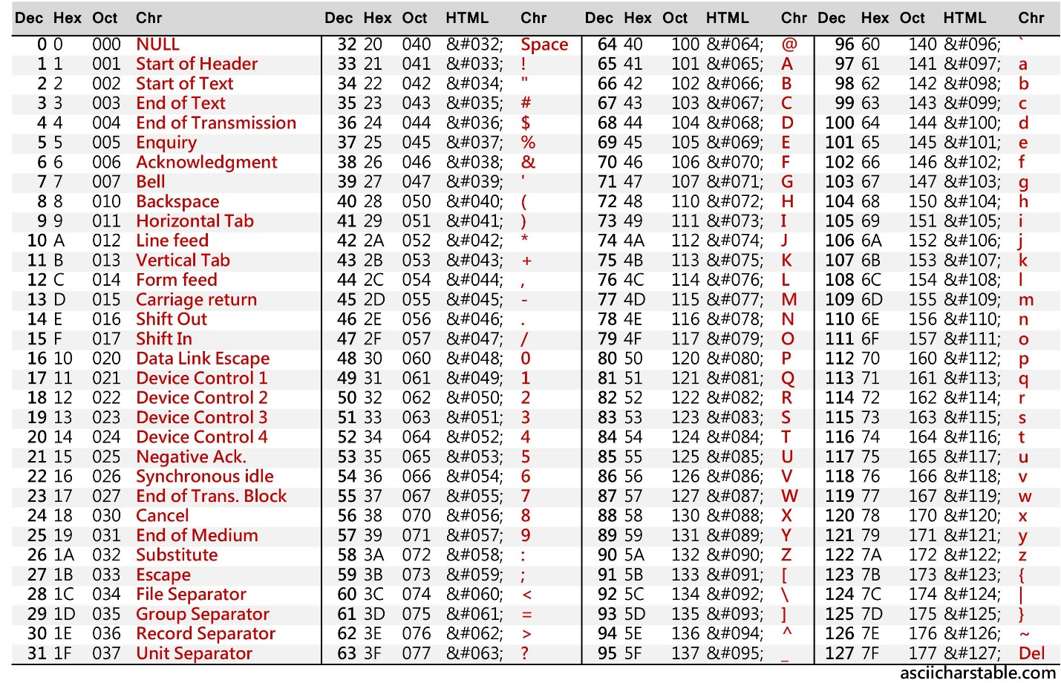

**Console Input**

• Requirements

o **#include <iostream>**

• cin

o **cin >> variable;**

• simple console input into a string variable

o **string day;** // *declare a variable called day*

o **cin >> day;** // *request console input, store into variable*

o **cout << day;** // *printout the value stored in the variable*

**Column Output**

#include <iostream>

#include <string>

#include <iomanip>

using namespace std;

**Number Format**

cout.setf(ios::fixed);

cout.setf(ios::showpoint);

cout.precision(x);

x specifies the number of decimal places

setw(y)

y specifies the number of characters in the column

float f1 = 4.5678;

float f2 = 6.2;

cout << setw(10) << setprecision(3) << f1 << setw(8) << setprecision(1) << f2;

**Basic Console Output**

• Requirements

o **#include <iostream>**

o This library provides console input and output support.

• **cout**

o cout << “Some text”;

• **endl**

o cout << “Some text” << endl;

• **\n**

o cout << “Some text\n”;

o cout << some variable << endl;

• **\t**

o cout << “The score is:\t 50\n”;